

Application for a Cold Cot or Cuddle Cot

From

Your Organisation Name

About Your Organisation
Name of your organisation
Full address
Contact person at your organisation
Role/ Job Title
E-mail
Phone

Please tell us briefly about your organisation, and how the requested piece of equipment will help you support or provide a service to bereaved parents and their families. Please include information about your existing provision, and explain how the equipment would lead to improvements.

About Cold Cots
A Cold Cot is the term used to describe a specialist piece of refrigerated equipment designed to keep a baby’s body cool after death. The main purpose of a cold cot is to slow down the natural changes in the baby. This gives parents more time to:
- be with their baby
- create lasting memories
- make important decisions regarding their baby without feeling pressured in any way
- arrange for family and friends to meet their baby
It may be possible for parents to take their baby home in the Cold Cot.
Hospitals typically prefer one of the following two models. Sands can fundraise for either model, and would be happy to consider any alternative products.

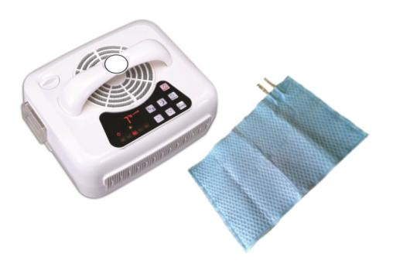
Covercool by Flexmort
A small cooling machine circulates cold fluid to a small, flexible cooling blanket, which is placed under the baby. The cold blanket reduces the baby’s core body temperature through direct contact. The blanket can be replaced or cleaned with warm water or antibacterial wipes after use. http://flexmort.com/
The machine weighs 3.8kg and measures 27cm x 23cm x 13cm

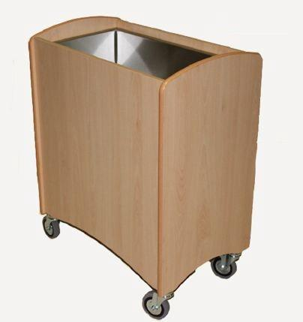
Refrigerated Cot by Demeva
A hygienic stainless steel well with an underslung condensing unit, housed within a beech-effect finished case, designed to blend in with other hospital furniture. It can be cleaned with warm water or antibacterial wipes. www.refrigeratedcots.co.uk
The unit weighs 90kg and measures 70cm x 30cm x 80cm

Type of cot required (Please tick)

Covercool by Flexmort

Refrigerated Cot by Demeva

Alternative product (please specify)

Agreement
Please read carefully and confirm that, if you were to receive a cot (the Equipment), your organisation (the Grantee) could commit to the following by ticking or writing yes in the box to the right.
The Equipment is solely for the use of bereaved families, and the Grantee will always make it available to them when their baby dies, unless it is already in use by another family
All Health and Safety requirements, applicable employment and equality law, and applicable guidance and Regulatory requirements relating to the ownership and use of the Equipment are the responsibility of the Grantee, and Sands accepts no liability and offers no indemnity for any harm caused arising from negligence, gross negligence, or intentional misuse of any of the Equipment gifted in kind to the Grantee
All maintenance and repair work supporting the continued safe use of the Equipment is the responsibility of the Grantee, and Sands accepts no liability for this
Sands accepts no liability for replacing any Equipment that breaks or requires replacing after normal wear and tear; however, Sands welcomes the opportunity to discuss such requests
The Grantee must put in place and maintain in force at its own cost appropriate insurance for the Equipment, together with sufficient employee and third party liability insurance in place to indemnify Sands from any claims arising from negligence, gross negligence or intentional misuse of any of the Equipment gifted in kind to the Grantee
The Grantee must report to Sands on the use of the Equipment. Those reports must contain the information and be in the format and delivered at the frequency and to the timescales, as Sands reasonably requests. The Grantee must also provide Sands with all reasonable assistance and co-operation in relation to any ad hoc information requests made by Sands in relation to the Equipment
The Grantee must obtain Sands’ prior written approval (not to be unreasonably withheld) for any publicity in connection with the Grantee’s receipt of the Equipment, and acknowledge Sands’ donation in any publicity about the Items, including prominent display of Sands’ logo
The Grantee must coordinate with Sands over a presentation ceremony and the application of a commemorative plaque to the Equipment, and not unreasonably deny any such requests
The grantee must observe its obligations under FOIA, DPA (including GDPR), EIR and HRA, and under the common law duty of confidentiality, as appropriate
The total liability of Sands is limited to the gift of the Equipment

What Happens Next?
Please return your completed application to volunteering@sands.org.uk
Sands will consider all applications and respond within two weeks from receipt of this completed form. Sands receives many such requests and aims to prioritise according to need. Our goal is to ensure a cold cot is always available when it is needed by a bereaved family, and we are proud to support the NHS to make this a reality.

Fundraising
Sometimes Sands can donate a cot immediately, and sometimes a short fundraising campaign will be required before the item can be bought. We will discuss this with you at the start of the process.

Donating the Cot
Sands will make the purchase when the funds are available and arrange for delivery. Where possible, we will work with you to organise a presentation.
Application completed by
Signed
(N.B. By signing I confirm I hold the necessary authority to engage in this agreement on behalf of the Grantee)
Date

